The Role of Life Skills in Promoting Mental Health
Key Benefits of Acquiring Life Skills
Better Decision-Making
Encourages responsible choices by improving analytical and critical thinking skills.
Effective Stress Management
Equips individuals with tools to cope with stress, frustration, and daily pressures in healthy ways.
Enhanced Communication Skills
Promotes clear expression, active listening, and healthy interpersonal relationships.

Greater Self-Awareness and Self-Esteem
Builds a deeper understanding of one’s emotions, strengths, and weaknesses, leading to higher confidence.

Strengthened Interpersonal Relationships
Encourages empathy, cooperation, and conflict resolution in personal and professional settings.
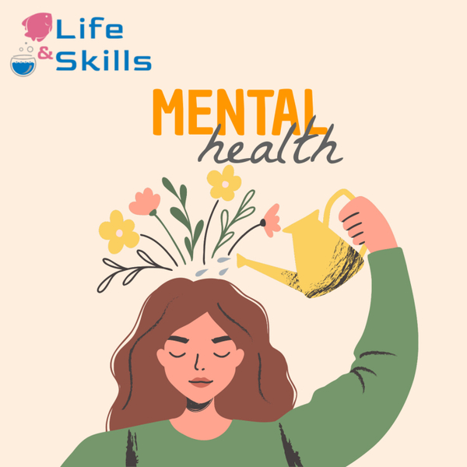

Definition of Life Skills

Life skills are defined as “abilities for adaptive and positive behavior that enable individuals to deal effectively with the demands and challenges of everyday life” (World Health Organization, 1997). These skills include a wide range of cognitive, emotional, and interpersonal competencies, such as decision-making, problem-solving, critical thinking, communication, self-awareness, empathy, and coping with stress and emotions.

What is the importance of learning life skills in mental health?
Life skills are essential abilities that enable individuals to deal effectively with the demands and challenges of everyday life. According to the World Health Organization (WHO), these skills—such as emotional regulation, problem-solving, decision-making, interpersonal communication, and stress management—play a crucial role in enhancing psychological well-being and preventing mental disorders.
Life skills can improve mental health

Studies on the role of life skills in promoting mental health
Studies have shown that life skills training can significantly improve self-esteem, resilience, and emotional intelligence, which are protective factors against anxiety, depression, and substance abuse. By empowering individuals to handle stress, build healthy relationships, and make responsible choices, life skills contribute to better coping strategies and a more stable mental state.
For example, research by Nasheeda et al. (2019) indicates that life skills education in adolescents not only reduces behavioral problems but also fosters a sense of purpose and emotional balance. As mental health becomes an increasing concern globally, especially among youth, integrating life skills into educational and community programs is a proactive approach to cultivating mental resilience.

Reference
Nasheeda, A., Abdullah, H. B., Krauss, S. E., & Ahmed, N. B. (2019). A narrative systematic review of life skills education: effectiveness, research gaps and priorities. International Journal of Adolescence and Youth, 24(3), 362–379.
World Health Organization. (1997). Life skills education for children and adolescents in schools. Geneva: WHO.
Company Name
Street Address
City, ST ZIP Code
Recipient Name
Street Address
City, ST ZIP Code

